

eNotification
Software Architecture Document

Electronic Research Administration (eRA)
Integration Support Project

Version No: 1.0
Final as of 09-30-2004

Author: Natasha Globus
Team: Architecture Team
Client: National Institutes of Health (NIH), U.S. Department of Health and Human Services

Document Number: eNotSAD
Contract Number: 467-FZ-302102
© Copyright 2004 by International Business Machines Corporation.
All rights reserved.

Document History

Document Location
Ensure that this document is current. Printed documents and locally copied files may become obsolete due to changes to the master document. The source of the document is located in ClearCase j2ee_internal/eNotification/docs/Architecture.

Revision History
Version Number | Revision Date | Author | Summary of Changes
0.1 | 09-17-04 | Natasha Globus  Ammar Albadarneh | Initial version
1.0 | 09-30-04 | Natasha Globus | Added peer review comments. Finalized document.

IBM Internal Reviews
Name | Team/Role | Version and  Date Reviewed | Reviewer’s Signature
Natasha Globus | Author
Ammar Albadarneh | Author
Changqing Zhen | Team Lead
Kalpesh Patel | Software Architect
Abhi Jain | Software Architect

Client Reviews
Name | Team/Role | Version and  Date Reviewed | Reviewer Comments

Reference Documents
Document Name | Version
eNotification Vision.doc | CC
eNotification - Glossary | CC
eNotification Use Case Model Survey.doc | CC
eNotification Supplementary Specifications.doc | CC
eNotification Architectural Guidelines.doc | CC

Table of Contents
1. Introduction 1
1.1. Overview 1
1.2. Purpose and Objective 1
1.3. Scope 1
1.4. Definitions, Acronyms, and Abbreviations 1
2. Architectural Representation 2
3. Architectural Goals and Constraints 2
4. Use-Case View 2
4.1. Use-Case Realizations 2
5. Logical View 3
6. Process View 3
6.1. User Group Registration 4
6.2. User Group to Event Registration 4
6.3. Event processing 4
6.3.1. Process Flow 4
6.3.2. Event Engine Component Interface 5
6.3.3. Queuing Technology 6
6.3.4. Event Processor 6
6.4. Work List Acknowledgement 7
6.4.1. Process Flow 7
6.4.2. Work list Component interface 7
6.5. Monitoring 7
6.6. Process Example 7
7. Deployment View 8
8. Data View 8

- Introduction

Overview

This Software Architecture Document provides software architecture and high level design for the new eRA eNotification system. This document will be used as a recommendation and guideline by the development team to develop detail design for the system. It emphasizes the architecturally significant parts of the design model.

Purpose and Objective

The purpose of this document is to provide high-level architectural guidelines for the eNotification task.
The intended audience of this document is the eNotification task manager, Architecture Group and the development team members of the task.

Scope

This document focuses on the first iteration of the eNotificationt task. The focus of the first iteration is to implement Manage User Groups, Manage Registration of User Groups to Event, Process Event, and Manage User Event Queue Use Cases. Detailed design and implementation will not be addressed in this document and will be left to define for development team.

Definitions, Acronyms, and Abbreviations
For Definitions, Acronyms, and Abbreviations please refer to eNotification – Glossary.

Architectural Representation
Presented in this document is the high-level software architecture approach for a new eNotification system. This approach is represented through Use-Case, Process, Deployment, and Data Views.

Architectural Goals and Constraints
The standard eRA hardware and software environment shall be used during the eNotification task implementation. The eRA system is standardizing on the J2EE platform. The major technologies used are from Oracle including Oracle Application Server 9i and Oracle Relational Database 10g. Both application and database servers are currently running on the UNIX operating system. In addition standard J2EE framework services based on Struts and common J2EE design patterns developed by the eRA project team shall be used as a base for the j2EE development.

Use-Case View
eNotification Use Cases can be grouped into several major sets based on actors and functionality. Those groups are following:
Administration includes following activities:
- Create user groups with defined user list
- Register a group with an event
- Define notification options for an event (email, print, etc) – Future iterations.

Notification Engine performs following activities:
- Process event s from the event queue.
- Update user’s work list
- Process eNotifications options like email – Future iteration.

User acknowledgement represents how User manages the work list.
Help Desk manages the event queue – Future iteration.

Use-Case Realizations

This section illustrates how the software works by providing realization of the use-cases selected for the first iteration and explains how the various design model elements contribute to their functionality.
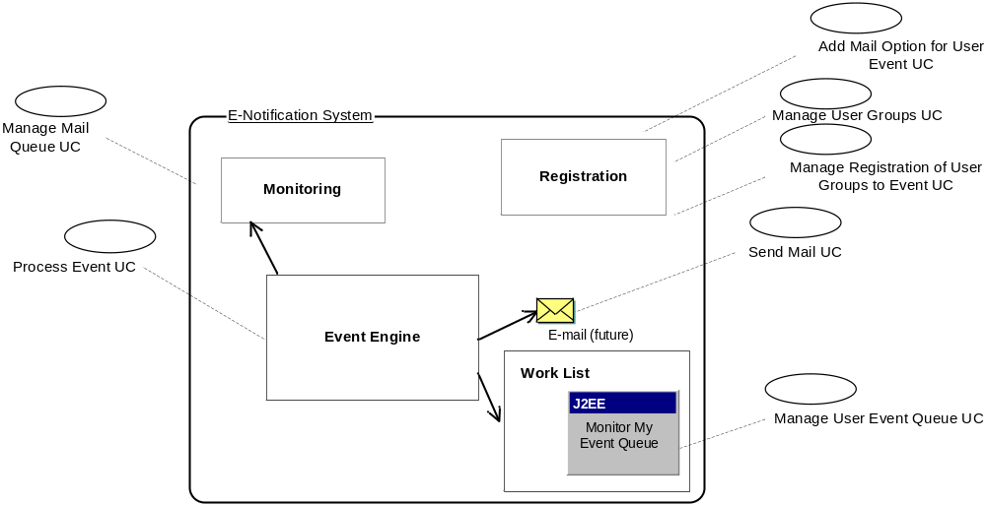
Use Case Realization View

Manage User Groups and Manage Registration of User Groups Use Cases will be realized through the separate Registration component. This component will be accessible only for users with a specially defined role. Manage User Groups Use Case will be implemented providing a facility to define User Group based on attributes defined in Supplementary Specification. Manage Registration of User Groups Use Case will provide a user with the facility to assign User Groups to Events. Add Mail Option for User Event will also be processed through Registration component.
Process Event Use Case will be realized through Event Engine component. An external system will trace an event and call eNotification system to process it. The input interface for eNotification system will accept event identification and store it into the queue. As soon as the event is registered into the queue, a listener will call Event Processor. This process shall log the event information, determine all user groups registered to receive the event; shall process the information and prepare the data to be displayed to the registered users. Send Mail Use Case will be realized here as well.
Manage User Event Queue Use Case will be implemented through Work list component. The eNotification Work List will display all occurred events for each user registered to see these events.
Manage Mail Queue Use Cases will be realized through Monitoring component.
Add Mail Option for User Event, Send Mail and Manage Mail Queue Use Cases will not be implemented for the first iteration.

Logical View
Logical View of the design model, such as its decomposition into subsystems and packages will be determined during development phase of the task.

Process View
This section describes the system's decomposition into various processes and components.
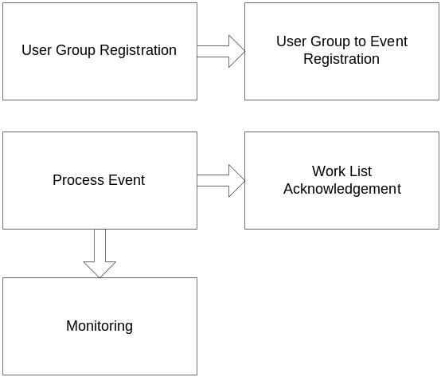
Process View
The eNotification system consists of several processes:
- User Group Registration
- User Group to Event Registration
- Event Processing
- Work List Acknowledgement
- Monitoring

User Group Registration

For the User Group Registration an Administrator shall be able to define User Group name and description, Entity Type of Event this group can be registered for (Grant Application, Meeting etc), and Group User Type (users, institutions, meetings etc). In addition to these attributes an Administrator will be able to define User Group SQL statement. The SELECT clause of this statement is based on Group User Type database association (person_id, external_org_id etc).The WHERE clause of the SQL statement may contain dynamic parameter association (variable binding). This association should be replaced during event processing with input value of Event Entity ID. See section 6.6 for detailed example.

User Group to Event Registration

Each User Group will be created for only one Group User Type. A User Group can be registered only for one type of Event.

Event processing

Process Flow

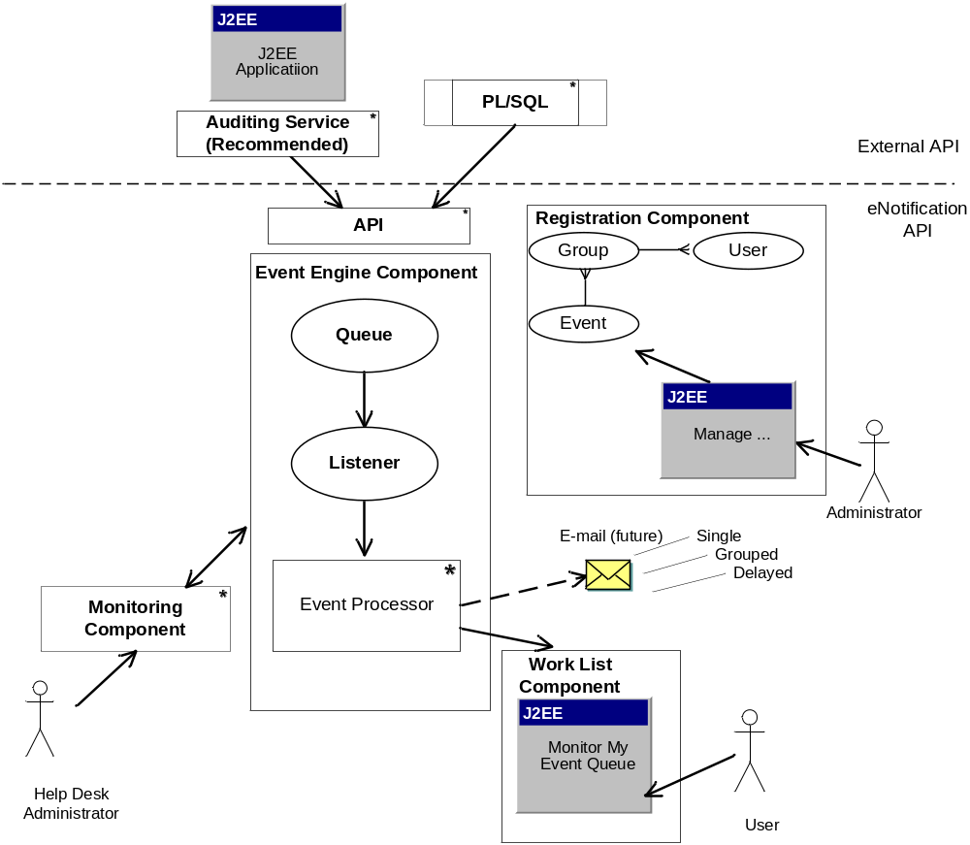
Event Process Flow

1) External Application will call the eNotification API to handle the event notification. The calling application may choose to audit the Event information in the Auditing service prior to calling the eNotificaiton API. In that case calling application will obtain an Audit ID, identifying the audited information.
2) The API will then register an Event occurrence.
3) Event Listener shall de-queue the information and pass it to the Event Processor.
4) Event Processor shall process received information.

Event Engine Component Interface

The event processing system can be invoked from the various API sources. These sources include but are not limited to J2EE applications or PL/SQL code.
The eNotification Event Engine interface signature shall be identical for all the calling sources. It shall include:
- Event Name – unique event identifier
- Event Entity Key ID – ID of the business entity for which the Event is triggered (appl_id => 12345)
- User ID – ID of the user who triggered the Event
- Triggered Date - Date/Time when the Event occurred
- System Name - calling system name. Optional.
- Auditing Identifier – an identifier from the Auditing Service. Currently applies to J2EE application. Optional.
For the first iteration the API shall be called for each Event Entity Key ID individually.

Queuing Technology

Advanced Queuing is a feature of the Oracle database that provides message queuing functionality. A big advantage of Advanced Queuing is that it can be accessed from PL/SQL or Java, so it can en-queue a message from a Java and de-queue that same message in a PL/SQL stored procedure.
As an interface from existing eRA J2EE applications a new Framework Service eNotification.storeEvent (event VO) shall be developed. This service shall invoke Advanced Queuing (AQ), operations through the Java Messaging System (JMS).
En-queue messages to Java Messaging System (JMS) queues from PL/SQL shall be performed using the DBMS_AQ and DBMS_AQJMS built-in packages. A wrapper procedure with the interface parameters shall be developed.
The system accepts Event related parameters by en-queuing a message to AQ, which is consumed by a Message-Driven Bean (MDB) as a listener that calls event engine process. A Java Message-driven Bean is a type of Enterprise JavaBean (EJB) that is automatically invoked whenever a new message arrives into a watched queue. An MDB that receives an AQ message calls Event Processor.
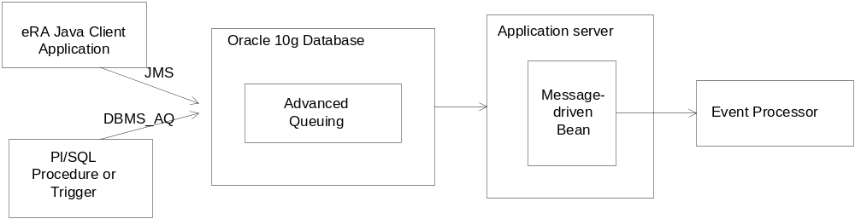
Queuing Architecture

Event Processor

Process Event engine shall process event log information received from MDB and store it into the database using Data Service Layer. The system should be flexible enough to accommodate future iteration requirement of sending single email per user per event, consolidated email and process mail delays.
Event Processor shall:
- Log an event with the appropriate attributes specified in the Supplementary Specification into the database
- Identify all User Groups registered to receive the Event
- Find all the members of each group by executing SQL statement which is defined as an attribute for each User Group. Use Event Entity Type Key as a parameter to the SQL statement if it’s defined dynamically.
- Save User Event information into the Database for the future retrieval

Work List Acknowledgement

Process Flow

Work List component shall display User Event Information to User based on User Events entry from the database. After User acknowledges an Event, User Events entry shall change its status and disappear from the screen. For the first iteration User will be able to acknowledge Events one by one only.

Work list Component interface

Work list component shall have common user interface, so that it can be easily implemented by various eRA J2EE applications that wish to display the Worklist to their users outside ICAdmin.

Monitoring

Monitoring process shall consume Event log information and Auditing service information. This process will not be implemented for the first iteration.
Monitoring component shall have common user interface.

Process Example

Pre-condition:
A new event E-Snap Submitted for Event Entity Type – Grant Application (appl_id) is defined.
The event occurred and E-Snap J2EE Application. E-Snap audited the event and received audit_id = 100. E-Snap called eNotification API.
Group Registration:
A new group name – “Individuals” with Event Entity Type - Grant Application (appl_id), User Type – Person Profile (person_id) is defined. This group has following SQL attribute : SELECT person_id FROM person_involvements_t WHERE person_type_code = ‘PI’ AND version_code =’A’ AND appl_id = ?
This group is registered to receive E-Snap Submitted Notification as both Even and User Group have the same Event Entity Type.
Process engine:
- The engine will accept Event Identification, E-Snap Submitted in our case; Event Entity Id – Appl_id equal to 12345; Event initiator User Name; Event initiated Date; Event initiator module – E-Snap Application, Auditing Identifier audit_id = 100.
- The system will save the log information into the database as following: Event Identification - E-Snap Submitted, Event Entity Key appl_id equal to 12345, Event initiator User Name, Event initiated Date, Event initiator module – E-Snap Application, Auditing Identifier audit_id = 100.
- The system will identify that “Individuals” group is registered for E-Snap Submitted Event.
- Execute group SQL statement replacing “?” with Event Entity Key ID 12345.
- Record results into the Database for each found User Type. In our example it will be following: User Type – person_id, User Type Key – result of the SQL execution person_id equal to 9999, Event Identification - E-Snap Submitted, Event Entity Key appl_id equal to 12345.
Note: the example doesn’t reflect physical data model design, but rather illustrates logical aim.
Acknowledge Work List:
The system will show all User Event Queue entries grouped by Business Entities.

Deployment View
This section describes the physical network (hardware) configurations on which the software is deployed and run.
For the current eRA environment the following deployment configuration into the test environment is proposed:
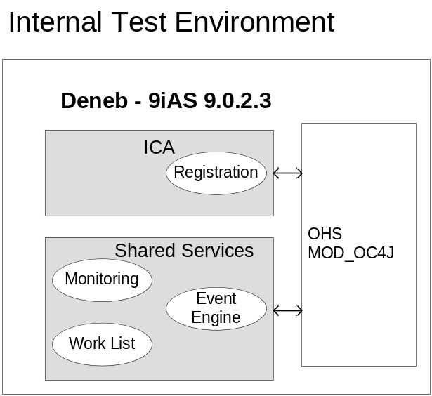

For the production environment the deployment architecture will be similar to presented above with the difference in hardware. Instead of “Deneb” in production “Phobos” will be used.
eNotification system will be deployed as following:
Three components shall be design as shared components and deployed on Shared Services Container
- Monitoring
- Work List
- Event Engine
Registration component shall be deployed on IC Admin Container. This container will also call Event Engine as a shared component.

Data View
Derived from Design Model below is the preliminary Data Model design.
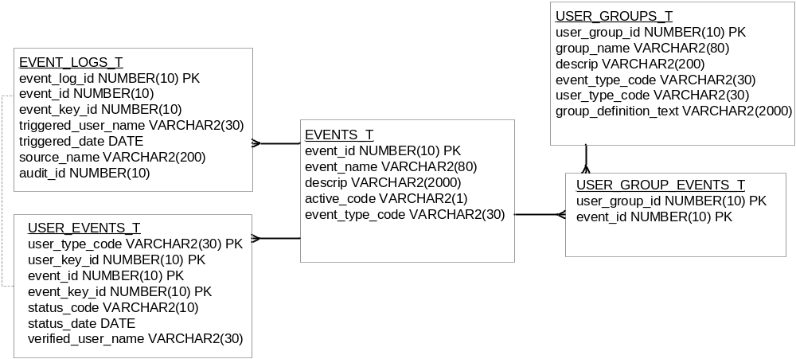
EVENTS_T is a lookup table for Events. It consists of generic event related information.
event_id is unique Event identifier.
event_name is the name of the Event.
descrip is the Event description.
active_code is indicating if the Event is being logged in and available to Administrator.
event_type_code is Event Business Entity Identifier. Valid values: ‘Grant Application’,’ Meeting’, etc.

USER_GROUPS_T is a placeholder for User Groups. This table gets populated and edited from the Registration component.
user_group_id is unique USER Group identifier.
group_name is the name of the User Group.
descrip is the User Group description.
event_type_code is Event Business Entity Identifier. Valid values: ‘Grant Application’,’ Meeting’, etc.
user_type_code is type of Users selected in the User Group, who are going to be notified for en event. Valid values: ‘Person Profile’,’ Meeting’, etc
group_definition_text is SQL statement that defines the group.

USER_GROUP_EVENTS_T is a table that reflects registration of User Groups to Events. This table defines intersection between User Groups and Events. This table has many to one relation with both EVENTS_T and USER_GROUPS_T tables.
user_group_id USER Group identifier.
event_id Event identifier.

EVENT_LOGS_T represents information logged for each ID of the business entity for each occurred Event. Every time an Event triggers, this table gets populated with detailed information on Event conditions.
event_log_id is unique Event log identifier.
event_id Event identifier.
event_key_id the ID of the business entity for which the Event is logged. If business entity is ‘Grant Application’ this column will contain the value of appl_id.
triggered_user_name is ID of the User who triggered the Event.
triggered_date is date when the Event occurred.
source_name is an application name where the Event occurred.
audit_id is Audit Service ID.

USER_EVENTS_T table represents User interaction with the Users work list of Events. This table keeps truck of User acknowledgement to the Event. The list of Users are identified in Event Processor component by executing SQL statement definition for each User Group registered to receive the Event.
user_type_code is type of Users selected in the User Group. Valid values: ‘Person Profile’,’ Meeting’, etc .
user_key_id the ID of the User selected in the User Group. If user type is ‘Person Profile’ this column will contain the value of person_id.
event_id Event identifier.
event_key_id the ID of the business entity for which the Event is logged. If business entity is ‘Grant Application’ this column will contain the value of appl_id.
status_code is indicating if the Event is being acknowledge.
status_date is indicating acknowledgement date.
verified_user_name is ID of the User who acknowledged the Event as it could be different from user_type_key.

